Deacon Harold Burke-Sivers
at St. Peter Cathedral
Thursday, Oct. 17th – 7 p.m.

“Living a Eucharistic Faith:
The Big Deal about Mass and Why it Matters”

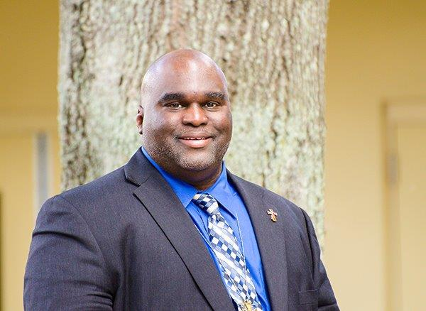

Deacon Harold Burke-Sivers is globaly recognized as a dynamic
and sought after speaker in the Catholic Church. He and his wife
live in Oregon, in the Portland Archdiocese. No charge for this
event, but a free-will offering will be taken up. Come!

